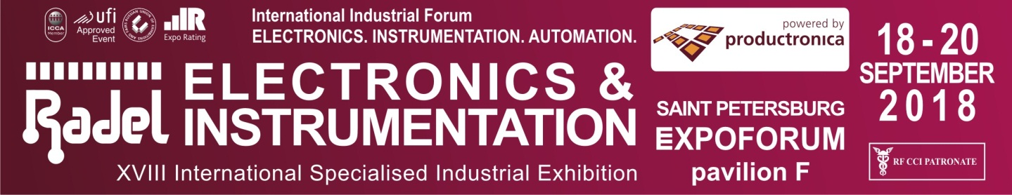 |  | Reg. №
ORDER FOR BUILDING, DESIGN, AND EQUIPMENT RENT | Attachment 1 to application-contract for exhibiting.
Company name _
Size of the rented space m х m = m².
Booth configuration (please tick an appropriate box ☑): - linear ( А ), - corner ( B ), - front ( C ), - islet ( D ).
Type of space (please tick an appropriate box ☑): - equipped*, - unequipped, independent construction*.

RENT OF EXHIBITION EQUIPMENT:
Design. | Description | Price | Q-ty | Amount
Power termination to 5 kW |  | 42
Power termination to 15 kW |  | 93
Power termination to 20 kW |  | 118
Carpeting (for unequipped space), m² |  | 10
 | Wall unit 1,0 х 2,5 m | 22
 | Wall unit 0,5 х 2,5 m | 17
 | Curved fascia board, R=1 m | 19
 | Folding door | 67
 | Hinged door | 67
 | Info counter 1х0,5, h =1,1 m | 44
 | Info counter with door. 1х0,5, h =1,1 m | 50
 | Info counter 0,5х0,5, h =1,1 m | 33
 | Curved info counter R=1, h=1,1 m | 63
 | Cabinet unit 1х0,5, h=0,7 m | 33
 | Showcase 1,0 х 0,5 х 1,1 m | 52
 | Showcase 0,5 х 0,5 х 1,1 m | 41
 | Showcase 1,0 х 0,5 х 2,5 m | 74
 | Showcase 0,5 х 0,5 х 2,5 m | 59
 | Podium 1,0 х 1,0, h=1,1 m | 38
 | Shelving (5 shelves) metallic | 30
 | Table D80 cm | 26
 | Table 80 х 80 cm | 26
 | Table 70 х 120 cm | 31
 | Bar table, h=1,2 м | 26
 | Upholstered chair (cloth covering) | 11
 | Bar chair (stool) | 14
 | Sofa, 140х85 cm | 147
 | Coatrack | 5
 | Waste-paper basket | 3
 | Magazine holder, 8 pockets | 19
 | Spotlight, 60 W | 19
 | Halogen floodlight 150 W | 15
 | Halogen floodlight 500 W | 30
 | Socket outlet, 220V | 16
 | Socket outlet, 380V | 44
 | Water station + 2 bottles of vodka | 55
 | Point of support, to 50 kg | 157
 | Windlass | 33
 | Prolyte-truss, lin m | 29
TOTAL = EUR
Full-line catalogue of exhibition equipment – www.en.farexpo.ru/stand

. DRAFT OF YOUR EXHIBITION BOOTH:
Please make sure that you specified location of lights, socket outlets, doors, showcases and other large-size equipment. You can copy symbols from the table – furniture would have to double, other elements are given in the scale. If the booth size is large, you can draw it on a separate sheet.

. DESIGN OF THE BOOTH:
Inscription on a fascia board: (up to 15 characters are free of charge, over 15 characters – 1 EUR per character)

For booths of «B», «C» and «D» types, please, specify quantity of inscriptions.
Service name |  |  |  |  |  |  |  |  |  | Price |  |  | Q-ty |  | Amount
Extra signs on a fascia board (1 letter) |  |  |  |  |  |  |  |  |  | 1
Logo on a board (1 color/extra color) |  |  |  |  |  |  |  |  |  | 34/10
Pasting with color tape, m² |  |  |  |  |  |  |  |  |  | 12
Full color printing of tape from exhibitor’s scratches and pasting, m² |  |  |  |  |  |  |  |  |  | 37
TOTAL = EUR
Notes.
* Not allowed:
- to mount your own equipment to booth constructions without the concurrence of the Exhibition directorate;
- to drill, fix advertising and other materials with pins, thumbtacks, hard-to-remove adhesive tape etc. No advertising materials, adhesive tape, etc. must be left after the exhibition.
In case of spoilage of the equipment an exhibitor shall recover its price.
Prices are noted including VAT.
----------------------------------------------------------------------------------------------------------------------------------------------------------------
Total due according to Attachment 1 (including VAT): + = EUR
rent of equipment design of booth
Responsible representative of the exhibiting company: / /

